Cultural Blunders
Student’s Name
Institution

Cultural Blunders
Activity 1
Marketing is not easy with poor cultural awareness and without a decent translator of the words or phrases used when designing marketing ads, commercials, and adverts. Cross-cultural marketing mistake can ruin a brand or even tarnish a business name in a foreign country. The following is a graphic showing the list of companies that created marketing blunders across different cultures in the past.

- Locum Company  Locum was a Swedish company. Just like many businesses do during the Christmas eve, it decided to redesign its logo to include it in its Christmas cards for its customers. In 1991, it decided to replace letter the “O” in the work Locum with a symbol of a heart as shown in the following picture. Many of its customers had mixed feelings towards the logo as it sounded and meant something different from what the company intended.   | - Umbro  In 2002, UK sports manufacturer (Umbro) was forced to withdraw its sneakers called Zyklon from the market. The name “Zyklon” was used by the Nazi regime to refer to a gas that murdered millions of Jews in the concentration camps and, therefore, did not fit well for the product.  
- Honda
In 2001, Honda designed a new car for marketing in Nordic countries. It named it “Fitta”. The company was forced to change the name to “Honda Jazz” as in Sweden, Norway, and Denmark, the name “Fitta” was a vulgar as it is a colloquial name assigned to women genitals.

- IKEA  IKEA is a Swedish furniture company that used the name FARTFULL for its new work benches. Well, the word “FARTFULL” in the following picture is a marketing blunder.  Swedish is a Germanic language, and fahrt is German for “travel”. Therefore, “fartfull” is used to suggest mobility. Swedes have several words for “fart”, which has different meanings as per their culture. One thing was clear, IKEA’s Marketing department was unaware what the words meant and, therefore, misused the FARTFULL, which had a different meaning to different cultures.  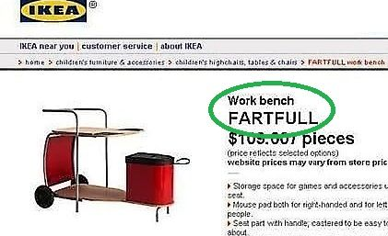 | - Wang  Wang was an American Computer Company that was trying to market its products in the British market. Unfortunately, in 1990s British territories refused to use the products because of the motto used in them that read “Wang Cares.”  Of course, Britons thought the motto meant “wankers”, which did not really give a positive image to the company.  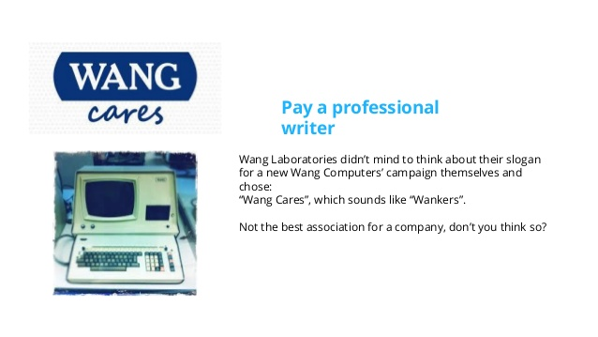

How to avoid similar issues?
The best thing to do in order to avoid similar issues, is to study international languages if possible and perhaps create diversified work teams that would help in every business move the business would be intending to make internationally. Top managers engaging in international business should research and learn more about cultural differences in order to avoid mistakes other companies have previously done. Adamczyk (2017) suggests that when planning to expand a business to other foreign countries, business managers should invest a lot of their time learning languages and about customs, values, and other elements of other cultures as this could help them avoid similar mistakes many business enterprises make in the global market.
When creating marketing campaigns either in form of commercials, ads, or even when looking for names to give their products, business managers should be sensitive to cultural differences. This does not mean changing the way a business do things, but looking for ways to integrate different cultures in a way that does not cause embarrassment of ruin the brand itself.

References
Adamczyk, M. (2017). The importance of cultural differences in international business. The Central European Review of Economics and Management, 1(2), 151-170.

